Woodturning Odd’s & Sods
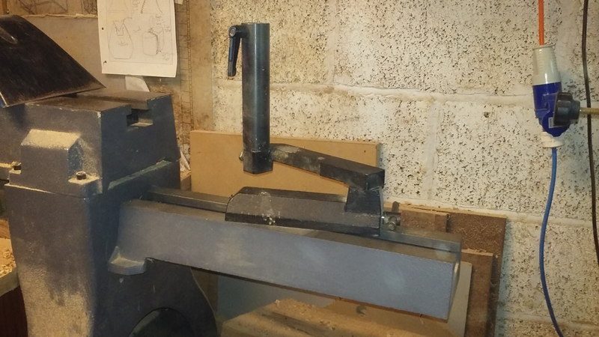
Axminster VSWL 1200 Bed extension& Toolpost

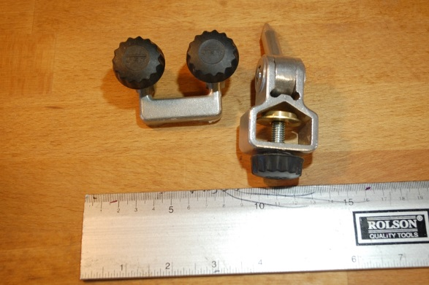
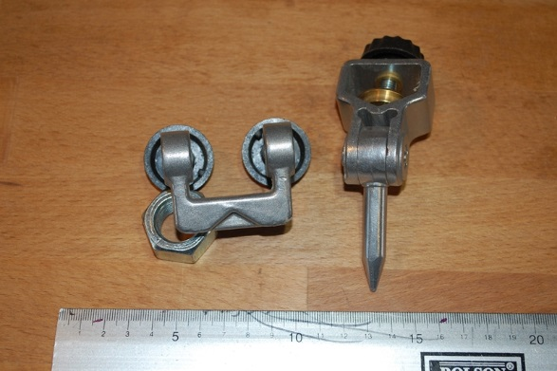
Jet Bowl Gouge Profiling Jig (for wet wheels)

£12 + Carriage

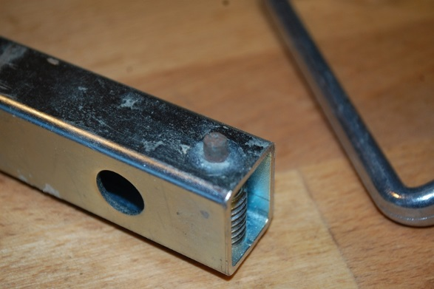
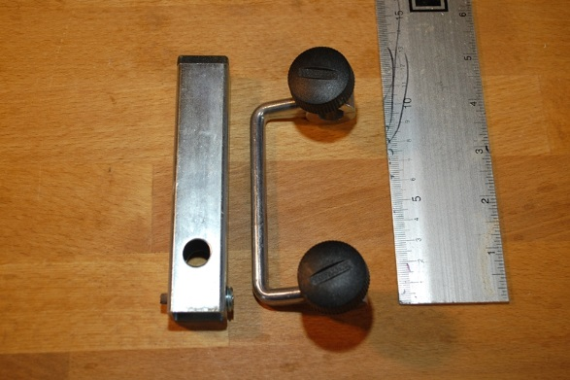
Tormeck Wheel Diamond Truing Tool

£30 + Carriage

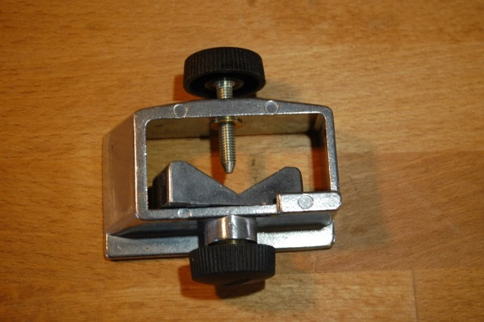
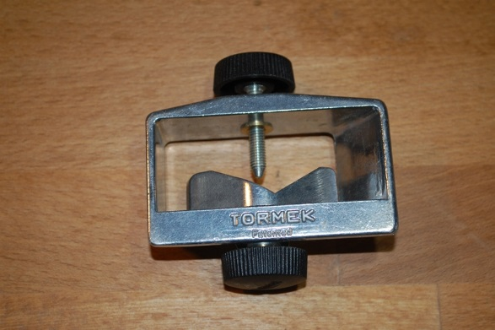
Tormek SVS-50 Multi-Jig (Open Seat attachement Only)

£25 + Carriage

