Chucks, Accessories & Jaws for Sale
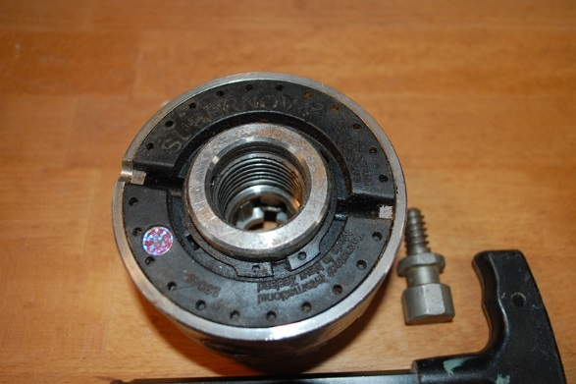

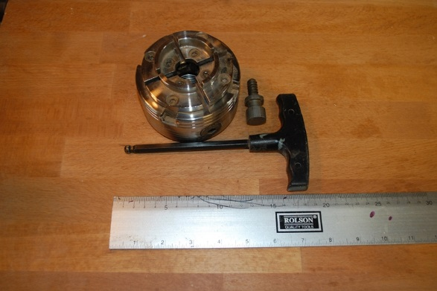

SuperNova II Chuck with C jaws, Screw Chuck & Wrench.
I believe the standard thread on these is M30 x 3.5mm Adaptors are available from Sorby or Charnwood (https://www.charnwood.net/products/chuck-thread-adaptors)

£80 + Carriage

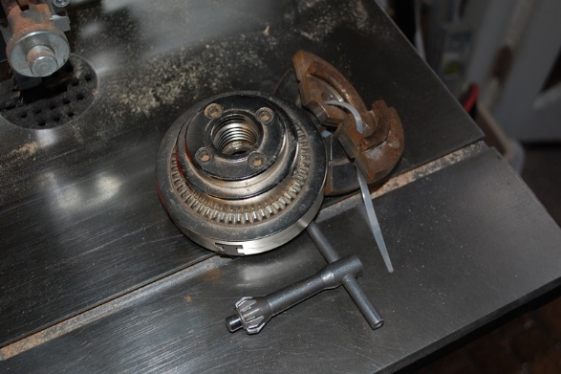
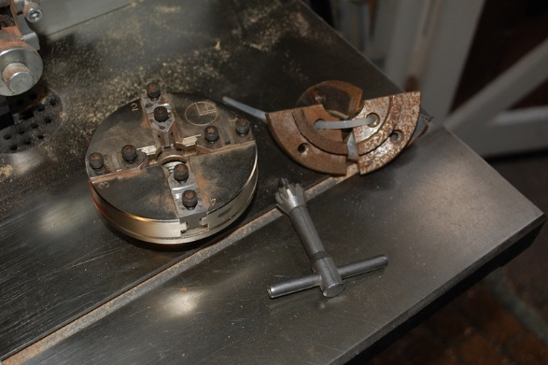
Axminster SK80 Clubman Chuck

£75 + carriage

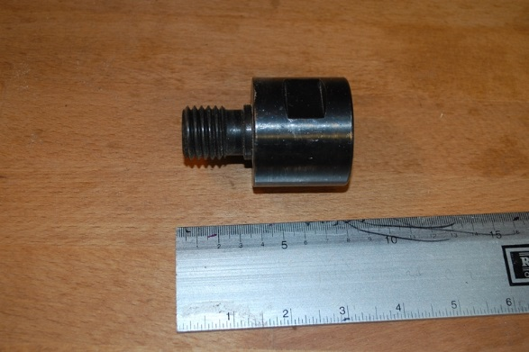

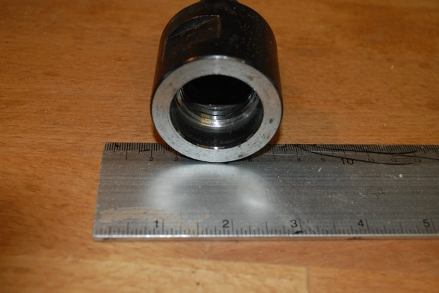

Thread Adaptor (Excert) for 1” x 8 Chuck Thread to M33 x 3.5mm Headstock Thread
£10 + Carriage

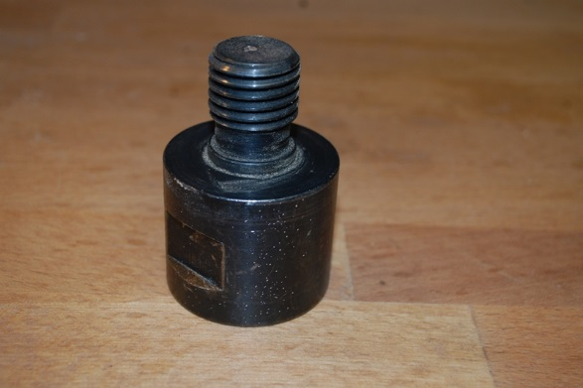

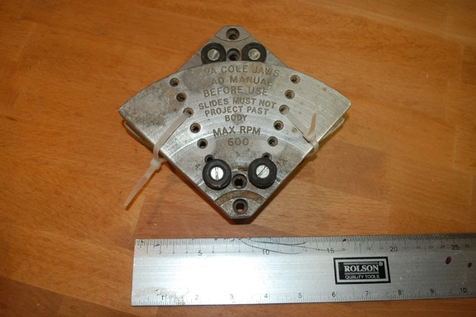

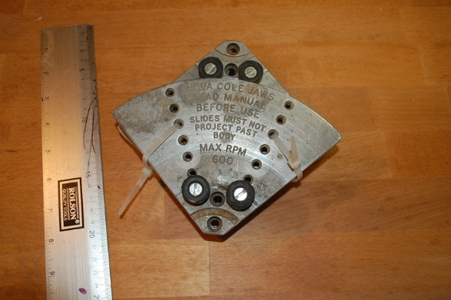

SuperNova Coles Jaws.

Will fit any Chuck with recesses in the Jaw Carriers.

e.g. SuperNova, Sorby Patriot, Vickmark and the Chinese copies and probably several others.

£25 + Carriage

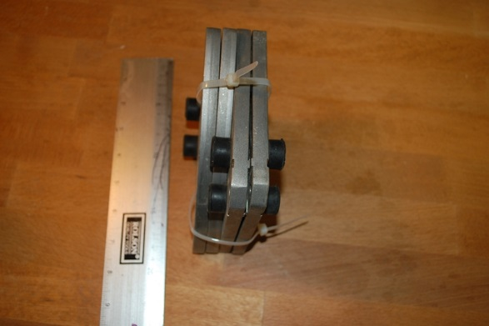

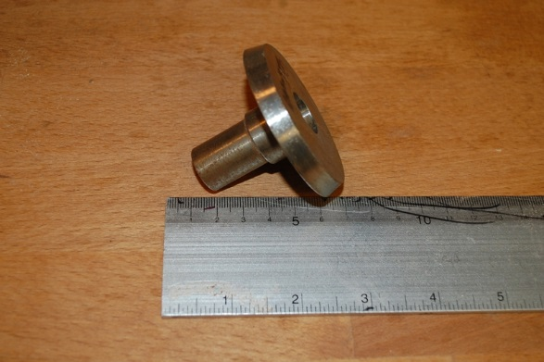
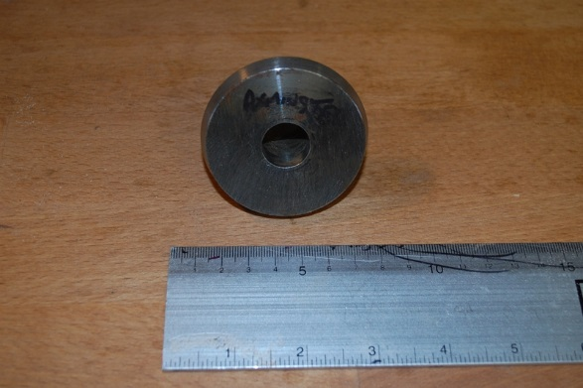
Axminster 2MT Carrier to fit any C Jaws

£7.50 + Carriage

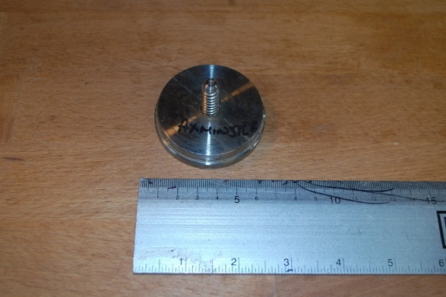
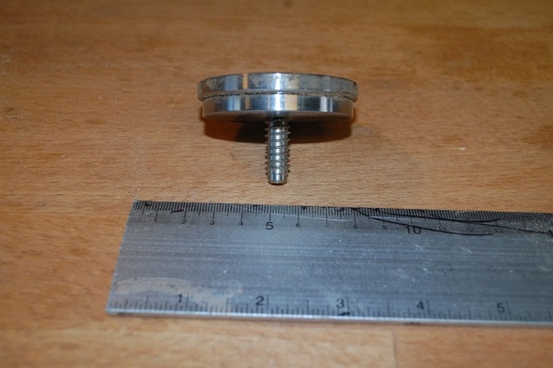
Axminster Screwchuck to fit any C Jaws

£12.50 + Carriage

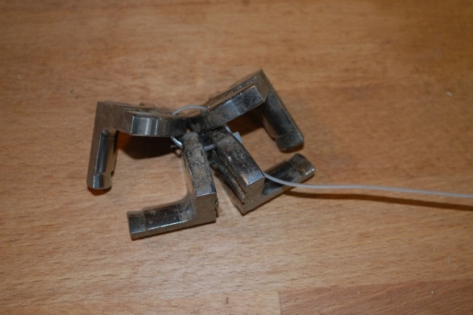
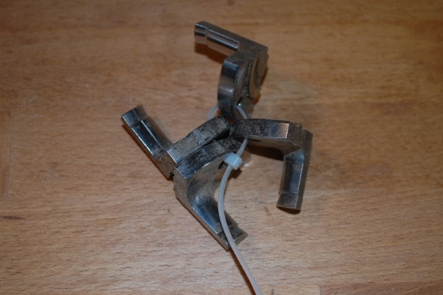
1 inch Pin Jaws to fit Chucks with Grove in Carriers

e.g. SuperNova, Sorby Patriot, Vickmark and the Chinese copies and probably several others.

£25 + Carriage

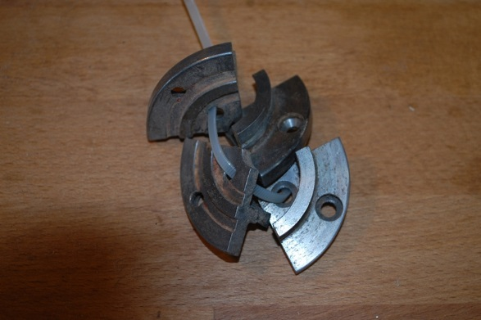
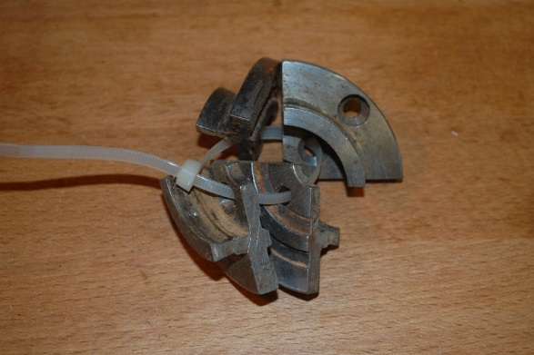

C Jaws to fit Chucks with Grove in Carriers

e.g. SuperNova, Sorby Patriot, Vickmark and the Chinese copies and probably several others

£25 + Carriage
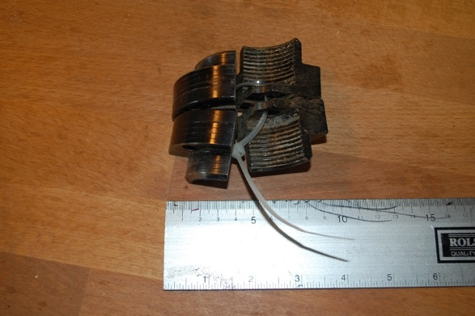

Deep Gripper jaws to fit Chuck with Groove in carriers

e.g. SuperNova, Sorby Patriot, Vickmark and the Chinese copies and probably several others

£30 + Carriage

